Separating Mixtures

Mixtures can be separated into their different parts by different methods according to the type of mixture involved.

Write down 4 methods of separating different types of mixtures:

1. _________________________________

2. _________________________________

3. _________________________________

4.__________________________________

1. Filtration of a Precipitate

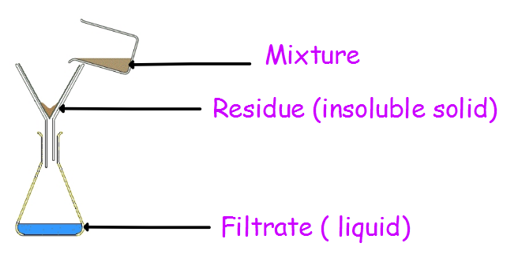

What type of mixture is this used to separate?

______________________________________________________________________________________________

2. Evaporation



What type of mixture is this used to separate?

______________________________________________________________________________________________

Filtration and Evaporation

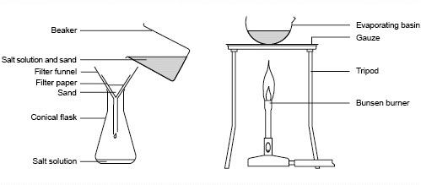

What type of mixture is this used to separate?

______________________________________________________________________________________________

3. Distillation

What type of mixture is this used to separate?

______________________________________________________________________________________________

When a mixture of two liquids is heated, the liquid with the lowest boiling point __________ first. The vapour is cooled in the ____________ and turns back to a liquid. This is then collected as the _____________.

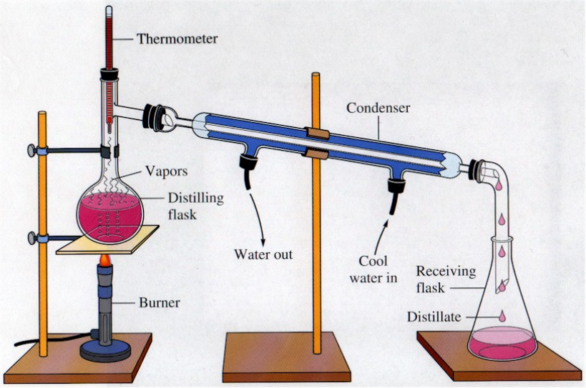

4. Chromatography



What type of mixture is this used to separate?

______________________________________________________________________________________________

It works because some of the coloured substances ____________ in the liquid better than others, so they travel ____________ up the paper.

Chromatography with different solvents

Which solvent was best at dissolving biro pen?

_________________________

Which type of pen dissolved in all the solvents?

_________________________

If a biro pen burst on your school shirt which solvent could you use to remove the stain?

_________________________