**You should answer the following questions.**

**Key area: Metals and alloys**

1 Metals are one of our most widely used materials.

(a) Gold is found uncombined in the Earth’s crust. What does this indicate about the reactivity of gold?

(b) The use of a metal depends on its properties.

Complete the table to show the property of the metal which makes it

suitable for each use.

Choose your answers from the following:

* conducts heat
* low density
* conducts electricity

|  |  |
| --- | --- |
| **Object** | **Property** |
| Aeroplane |  |
| Oven Tray |  |
| Copper Wires |  |

**Key area: Materials**

2

[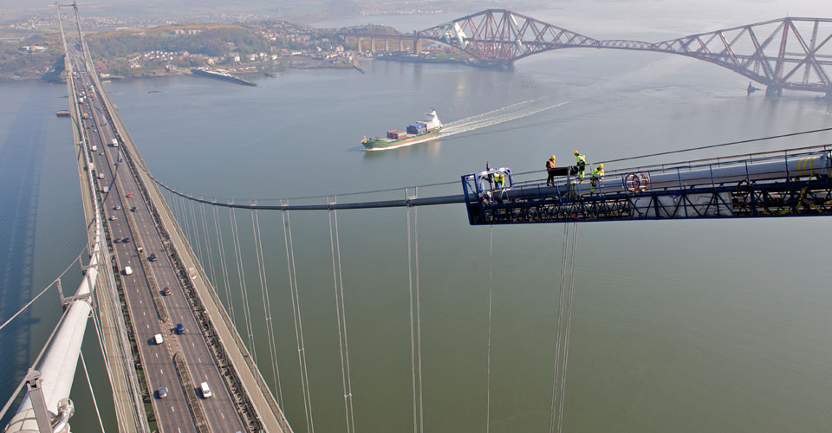](http://www.google.co.uk/url?sa=i&rct=j&q=galvanised+steel+cables+bridge&source=images&cd=&cad=rja&uact=8&ved=0CAcQjRw&url=http://www.istructe.org/structuralawards/2015/categories/sustainability-award/2010/forth-road-bridge-main-cable-project&ei=wzMUVYGhFNjxaK-JgfgN&psig=AFQjCNEXgq5Ibmf00TXqedRyVQ3AcIpPCA&ust=1427473715117106)

The above picture shows the galvanised steel cable used in the Forth road bridge

1. Name the metal used to galvanise the steel cables.

(b) Polymers are named based on the monomer used to make them.

1. Name the polymer made from the monomer butadiene.
2. Name the type of chemical reaction used to make plastics.

(iii) Butadiene can be used to make a thermosoftening plastic. Describe what is meant by the term thermosoftening plastic.

(c) The graph shows the mass of a PET plastice recyvled and wasted in a European country.

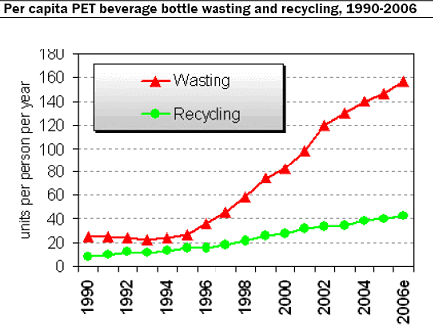

Year

Describe the general trend in the units of PET wasted between 2000 and 2006.

**Key area: Fertilisers**

3 Fertilisers are added to soil to provide essential elements required for

healthy plant growth.

(a) (i) Nitrogen is an essential element.

Name **two** other essential element required for healthy plant growth.

1. Why are fertilisers used?

(b) Name 2 properties fertilisers need to be useful?

(c) The solubility of a fertiliser in 100g of water is shown.

|  |  |
| --- | --- |
| *Temperature(oC)* | *Solubility (g)* |
| 10 | 28 |
| 20 | 38 |
| 30 | 48 |
| 40 | 58 |
| 50 |  |

(i) State the temperature at which 48 g of the fertiliser dissolves in 100g of water.

(ii) State the effect of increasing the temperature of the water on the solubility of the fertiliser.

(iii) Predict the solubility of the fertiliser in 100g of water at 50oC.

**Key area: Nuclear Chemistry**

4 Background radiation is all around.

State one natural and one artificial source of background radiation.

**Key area: Chemical analysis**

5The chart shows the pH range of soil in which different vegetables can grow successfully.

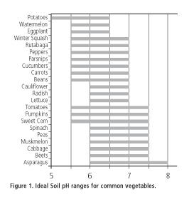

(a) State 3 ways the student could measure the pH of the soil.

(b) A soil has a pH value of 4. Calculate how much the pH of soil needs to be increased by, to allow cauliflower to grow successfully.