|  |  |  |
| --- | --- | --- |
|  | **If calling ask for:** | Alastair Gray |
| **Phone:** | 01555 896010 |
| **Date:** | 02 May 2018 |

Dear Parent/Carer

**Senior Phase Reports**

The Senior Phase Reports were due to be issued on Wednesday 25th September. Unfortunately, due to an ICT refresh, the Senior Phase Reports will now be issued to pupils one day later than planned, on **Thursday 26th September**.

Please contact me at the school if you have any further queries.

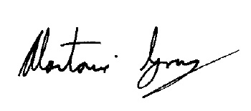Yours sincerely,

Alastair Gray

Depute Head Teacher