
Lesmahagow
High School

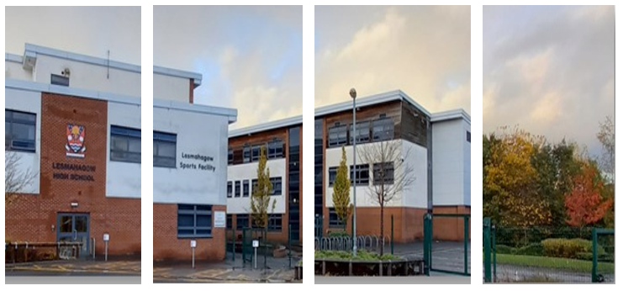

School Handbook
2023 – 2024

Handbook Contents
- Introduction Page 3

- About our School Page 7

- Parental Involvement Page 16
- School Ethos Page 17
- The Curriculum Page 23
- Assessment & Tracking Progress Page 28

- Reporting Page 29
- Transitions (Change of school/ Placing Requests) Page 29
- Support for Pupils (Additional Support Needs) Page 31
- Getting it Right for every child
- Enquire
- Attachment strategy

- School Improvement Page 35
- Pupil Equity Funding

- School Policies & Practical Information Page 36
- Nursery
- Free meals
- Uniform/dress code
- Clothing Grant
- Transport

- Foundation Apprenticeships Page 52
If you need this information in another language or format, please contact us to discuss how we can best meet your needs.
Phone: 0303 123 1023 Email: education@southlanarkshire.gov.uk.

1. Introduction by the Head Teacher
Welcome to our school handbook. My name is Barbara Lee and I am the Head Teacher. I hope our handbook provides you with helpful information about our school.
The purpose of this handbook is:
- to communicate the ethos of Lesmahagow High School;
- to offer you a practical resource which reassures you and helps you to prepare your child for secondary education;
- to give you a wide range of information about how the school operates;
- to give you an insight into what happens in the school and the opportunities available; and
- to encourage and facilitate partnership between us.

The information should be clearly signposted and you can access additional information through the links listed at the end. Much of the information is provided by South Lanarkshire Council, indicated by a star *. If there is any other information you need, please email me at headteacher@lesmahagow.s-lanark.sch.uk or phone me at 01555 896010.

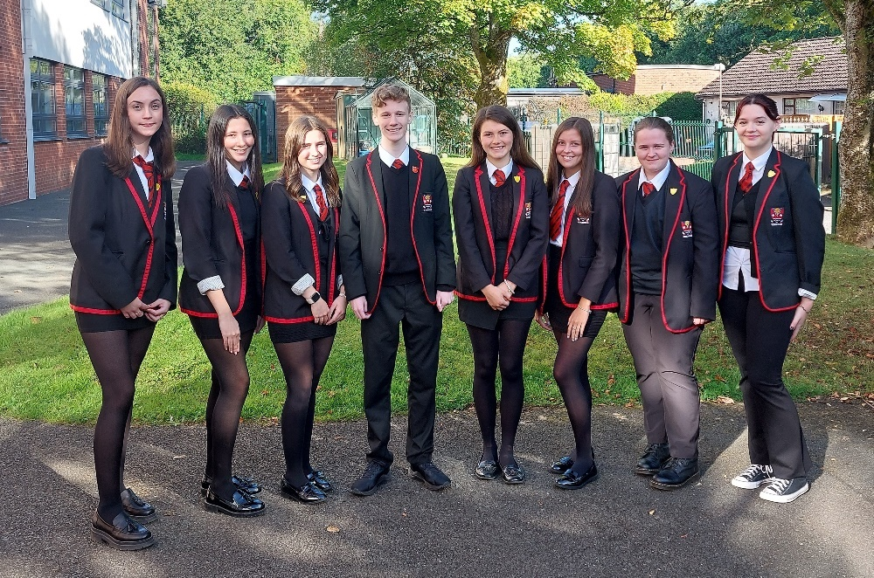
Abbey Kennedy and Olivia Smith (Health and Wellbeing Captains), Katie Laird (School Vice Captain), Luke Harold and Carrie Christie (School Captains), Ellie McKendrick (School Vice Captain), Cara Meikle and Caitlin Cairney (Equity and Inclusion Captains).

Our school
Lesmahagow High School is a 6-year comprehensive school serving the villages of Lesmahagow, Auchenheath, Blackwood, Coalburn, Hawksland, Kirkmuirhill and the areas surrounding each village. The school roll is 609 pupils (January 2024). A small school offers many advantages; one of the most important is that pupils are well known as individuals by staff, and they feel very much part of the school community.
The school was created close to the original school site and opened in August 2007. The school has a big “Street” area, bright wide corridors and two teaching blocks with high quality teaching facilities. This provides a modern learning environment for all subject areas. We are able to share many of the leisure facilities with the community.
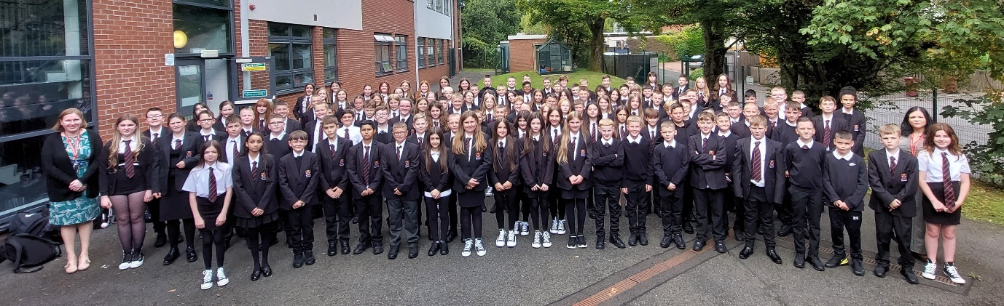
Our focus
Our focus is on people and on building strong relationships between pupils, staff, and parents. The quality of relationships between staff and pupils is crucial if all pupils are to blossom within the school. We have highly motivated, dedicated, and professional staff who work hard at creating an aspirational, caring, inclusive, welcoming atmosphere.
Learning and teaching is our first priority, and we are committed to providing a high-quality experience for all learners. Attainment and achievement are crucial features of school life, and we strive to enable all pupils to achieve their full potential, so they are prepared to succeed in the world beyond school.
We provide a caring and supportive environment where young people are listened to and feel successful, safe, and happy.
An extensive range of extra-curricular activities are available and the school is particularly strong in charity work, sporting activities, music, art, drama and providing a range of trips out of school.
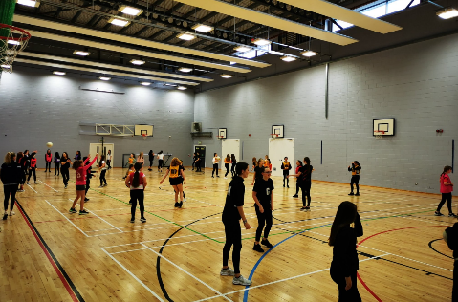

Our values
Our current shared values are respect, honesty, ambition, resilience and equity. These values permeate all aspects of our school, and the ethos within. Our vision – Aspire to be our best - for Lesmahagow High cannot be achieved without cooperation from our parents and carers. If there is anything that you want to know, or if you have any concerns or suggestions about how we may improve, please contact me at the school or get involved with our supportive and enthusiastic Parent Council. Further details can be found within this handbook.
We are all aware of the tremendous potential of our school and the people within it. Through the creation of positive partnerships with pupils, parents and staff, it is hoped that we shall all be proud to be associated with Lesmahagow High School.

Barbara Lee, Head Teacher

South Lanarkshire Council
South Lanarkshire Council is the fifth largest authority in Scotland. It covers the following main areas; Clydesdale in the south which features extensive rural areas, Cambuslang, Rutherglen, Blantyre and Uddingston to the north as well as the towns of East Kilbride and Hamilton.
The Council’s Plan Connect sets out the Council’s vision which is, “to improve the quality of life for all within South Lanarkshire”.
For Education Resources this means delivering services of the highest quality as well as striving to narrow the gap. It is about continually improving the services for everyone at the same time as giving priority to children, young people, families and communities in most need. The priorities for schools and services are set out in the Education Resources Plan which confirms the commitment to provide better learning opportunities and outcomes for children and young people.

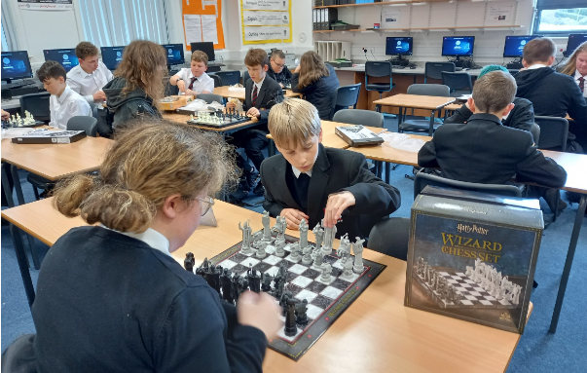

2. About our school
Lesmahagow High School
Strathaven Road
LESMAHAGOW
ML11 0FS

Phone 01555 896010
Fax 01555 896011
E-mail address office@lesmahagow.s-lanark.sch.uk
Website www.lesmahagow.s-lanark.sch.uk
Twitter @LesmahagowHigh

Lesmahagow High School is a non-denominational, co-educational secondary school covering years one to six. We do not provide teaching in Gaelic. The current school roll is 609 (January 2024).

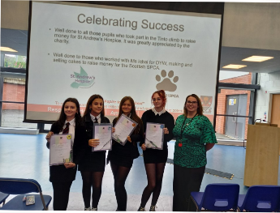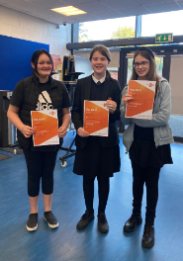
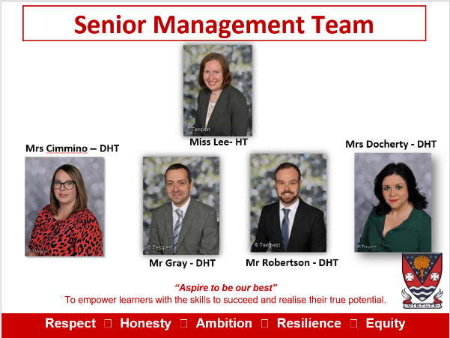
There are currently 54.5 full time equivalent members of teaching staff.
Languages Faculty
Miss L Parsons | Faculty Head
Mr J Mallaghan | Principal Teacher Pupil Support
Mrs Cimmino | Depute Head Teacher
Mrs L Quinn | Teacher of English
Mrs K Fair | Teacher of English
Mrs K De Fazio | Teacher of English
Mrs Wright | Principal Teacher of Pupil Support
Mrs C Travis | Principal Teacher of Support for Learning and Teacher of Inclusion
Ms L McMillan | Teacher of English
Mrs Anderson | Teacher of English & Inclusion
Ms E Tully | Teacher of Modern Languages
Miss L Stewart | Teacher of Modern Languages
Ms M McCallum | Teacher of Modern Languages
Expressive Arts Faculty
Mrs C Robertson Cheyne | Faculty Head
Mr S Stirling | Teacher of Music
Miss S Kilday | Teacher of Music
Miss L Clark | Teacher of Drama
Miss S Kelly | Teacher of Drama
Mr S Cameron | Teacher of Drama
Ms A Donaldson | Teacher of Drama
Mr G Sharp | Teacher of Art & Design
Mrs R Ritchie | Acting Faculty Head
Mrs L Simpson | Teacher of Art & Design
Mathematics Faculty
Mrs A Mullen | Faculty Head
Mr K Prentice | Teacher of Mathematics
Mr I Wallace | Teacher of Mathematics
Miss M Melvin | Teacher of Mathematics
Mr C Campbell | Teacher of Mathematics
Mrs N McCormack | Teacher of Mathematics
Health & Wellbeing Faculty
Mr N Ross | Faculty Head
Mrs B Winning | Teacher of Physical Education
Mr A Hill | Teacher of Physical Education
Mr J Hickson | Teacher of Physical Education & Inclusion
Mr Robertson | Depute Head Teacher
Mrs S Miller | Teacher of Home Economics
Mrs U Beveridge | Teacher of Home Economics
Mrs A McGhee | Teacher of Home Economics
Humanities Faculty
Mrs G Smith | Faculty Head
Mr M Smith | Teacher of History
Ms N Owens | Teacher of History
Ms B Lee | Head Teacher
Mr A Gray | Depute Head Teacher
Miss S Muldoon | Teacher of Geography
Miss S Leckenby | Teacher of Geography
Ms L Gray | Teacher of Geography
Mr A Rae | Teacher of History & Modern Studies
Ms A Gordon | Teacher of History & Modern Studies
Mr Rivans | Teacher of History & Inclusion
Miss A Fletcher | Acting Principal Teacher of Pupil Support
Mr E Gardner | Teacher of RMPS
Technologies & Digital Literacy Faculty
Mr Marc Campbell | Faculty Head
Mrs L Forbes | Teacher of Computing Science
Mr L McMillan | Teacher of Business Studies
Ms J Canning | Teacher of Business Studies
Mr F McMenemy | Teacher of Technical
Mr G Wilson | Teacher of Technical
Mrs D Queen | Teacher of Technical
Science Faculty
Ms C Wheeler | Faculty Head
Miss I Iqbal | Teacher of Biology
Miss N Forbes | Teacher of Biology
Mrs L Russell | Teacher of Biology
Dr E Brand | Teacher of Chemistry
Mrs H Dunn | Teacher of Chemistry
Mr G Milne | Teacher of Physics
Mr T Anderson | Teacher of Inclusion, Physics & Maths
Pupil Support Team
Mr Mallaghan | Principal Teacher of Kerse House
Miss A Fletcher | Acting Principal Teacher of Milton House
Mrs L Wright | Principal Teacher of Logan House
Support for Learning Team
Mrs M Storry | Principal Teacher Support for Learning
Mrs C Travis | Principal Teacher Support for Learning
Inclusion Support Team
Mrs R Anderson | Principal Teacher of Inclusion
Mr S Rivans | Teacher of Inclusion and History
Mr T Anderson | Teacher of Inclusion, Physics and Maths
Ms B Geurtzen | Teacher Inclusion
Support Team
Mrs L Yule | Support Services Coordinator
Mrs M Mitchell | Office Manager
Mrs L Forrest | School Support Assistant
Mrs A Barnes | School Support Assistant
Mrs B McFarlane | School Support Assistant
Mrs L Speirs | School Support Assistant
Mrs T Baillie | School Support Assistant
Mrs T McCallum | School Support Assistant
Mrs J Goulding | School Support Assistant
Mrs L Keenan | School Support Assistant
Mrs E Gill | School Support Assistant
Mrs J Wylie | School Support Assistant
Mr M Hobday | School Support Assistant
Mrs S MacLeod | School Support Assistant
Ms E Douglas | School Support Assistant
Mrs C Barr | School Support Assistant
Mrs J Thomson | School Librarian
Technicians
Mrs J Grierson | Senior Technician
Mr D Dobbs | AV Technician
Mr N Campbell | Technical Technician
Janitorial & Catering Team
Mrs J Wardrop | Janitor
Mrs L Miller | Cleaning/Caretaker
Mrs G Dyet | Catering
Mrs P Maxwell | Day Cleaner
Mr W Milne | SPIE
Mr J Shields | SPIE

Parent Council
Our Chairperson is Mrs Vicki O’Rourke and Secretary is Mrs Michelle Wailes. They can be contacted by emailing office@lesmahagow.s-lanark.sch.uk and marking the subject Parent Council. Emails will be transferred to the Parent Council unopened.

Contacting our school
The school can be contacted by phone or by email. You can decide to discuss your concerns with us either in person, or over the phone or via email – whatever suits you best and makes you most comfortable.
The best person to contact is your child’s Pupil Support Teacher, who is a Principal Teacher and in charge of a House group. This teacher has a particular responsibility for your child and will listen to your concerns, support you and your child, and/or advise you about what to do next. Most concerns can be settled by the PT Pupil Support. If your concern is about a particular subject, the PT Pupil Support will help you get in touch with the Principal Teacher in charge of that subject.
If your concern is not able to be resolved, the PT Pupil Support will put you in contact with the Depute Head Teacher who is in charge of your child’s House. The DHT will offer further support and keep the Head Teacher informed about your concern. You may bring your concerns eventually to the Head Teacher, who will do all he can to help you. If you continue to be concerned, you will be referred to South Lanarkshire Council.

Year | Depute Head Teacher | House | PT Pupil Support
S1 | Mrs Docherty | Milton | Ms Fletcher
S2 & S5 | Mr Gray | Logan | Mrs Wright
S3 & S6 | Mrs Cimmino | Kerse | Mr Mallaghan
S4 | Mr Robertson

The school is divided into 3 Houses: Kerse, Logan and Milton. Your child will be placed into a House when they enrol and stay in that House until they leave school. We try to ensure pupils are allocated to the same House as their brothers and/or sisters although this is not always practical or possible. The aim is to create a supportive, caring ethos within Houses and to build close relationships with those at home.

What to do if your child has to miss school
It is important for the school to work with parents in encouraging all children to attend school. All absences from school are required by law to be recorded. Absences will normally fall under two categories – authorised or unauthorised absence.
If you know in advance of any reason why your child is likely to be absent from school, please tell someone at the school, phone us or let us know in writing. Please also give your child a note on his/her return to school, telling us the reason for absence.

The school uses a text messaging system (Group Call) when a child in S1-S6 is absent from school and no previous notification has been given to the school. The system sends a message to the main contact person to inform them that their child is not present in school.
To ensure the safety of all our pupils we require parents to contact the school between 8.15am and 9.00am if they know that their child will be absent from school that day and no previous notification has been given.

The school phone number is 01555 896010.

If we do not receive any notification, a text message will be sent to the main contact number for your child.
If you receive a text message contact the school immediately to confirm the whereabouts of your child.

If your child stays off school without permission and without good reason this is called truancy.

Very occasionally a Group Call message is sent in error. We apologise should this occur but it is important that we chase up any pupils who appear to be absent. Should you ever receive a text message and you know your child is at school please contact us immediately so that we can confirm your child is safe and present in school.
It is very important that the school and families work together to ensure that pupils are in school and learning when they should be. It is especially important that we know our pupils are safe. Your contact phone numbers are not only used for absence but also to contact you if your child takes ill during the school day. It is vital that you inform us of any change to the following:
- Home phone number
- Mobile number
- Emergency contact details

Requests for your child to be absent from school to make an extended visit to relatives must be made in writing to the Head Teacher, detailing the reason, destination and duration of absence and arrangements for their continuing education. On these occasions the pupil will be marked as an authorised absentee in the register.
Information on emergencies
We make every effort to ensure the school remains open during term-time for pupils. However, on occasions circumstances may arise which can affect the school. Schools may be affected by, for example, severe weather, power failures or through any other circumstances that may impact on the school day. In such cases we shall do all we can to let you know as soon as possible. We shall keep in touch by the most appropriate method at the time normally through text message, and via our social media channels.
In cases of severe weather in the morning such as snow and a heavy frost and if there is a reason the school cannot open in the morning at the normal time, we will adopt the protocol for a delayed start until 10am.

If this is the case a message via social media and on the council’s website will be posted.

The Council’s website www.southlanarkshire.gov.uk will be used to let you know if the school is closed or has a delayed start. Further information will be provided later in the day as to whether the school will be open as normal the next day.

Things we need you to do:

- It is important for parents/carers to let the school know of any change to your mobile/home telephone number and change of address.

- If for any reason, you are unsure if the school is open visit the website www.southlanarkshire.gov.uk or email education@southlanarkshire.gov.uk

  - Your commitments

We ask that you:
- support and encourage your child’s learning – ask them what they have been doing.
- respect and adhere to the school’s policies and guidance.
- accept your responsibility to respect staff who work in the school and for the school to be proactive in taking forward its commitment to care for and educate your child.

Family holidays during term time
Every effort should be taken to avoid family holidays during term time as this both disrupts the child’s education and reduces learning time. If holidays are taken during times when the school is open parents should inform the school in advance by letter.

If your child is taken on a family holiday during term time then, in line with Scottish Government advice, this will be classified as an unauthorised absence. However, in exceptional circumstances schools may register a family holiday during term time as an authorised absence when, for example, parents are unable to obtain leave during the school holiday period.
Clearly, absence with no explanation from parents will mean that the absence will be recorded as unauthorised.

In our approach to raising achievement it is recognised that attendance at school is something that should be continuously encouraged. Parents/carers, children and the school all have a part to play in encouraging and stressing the importance of attendance at school.
Every effort should be made to ensure that your child attends school during term time. Please contact the school if your child is unable to attend school.

How to make a complaint
If you wish to make a complaint about any aspect of the school, please contact the school and ask to speak to the Depute Head Teacher in charge of your child’s year group – Mr Robertson for S3 and S6, Mr Gray for S1 and S4 and Mrs Cimmino for S2 and S5. A complaints form will be completed including your details and a summary of your complaint. This form is passed to the Head Teacher who will investigate your complaint. Either the Head Teacher or the Depute Head Teacher will report back to you within an agreed time or will contact you to explain any delay. You may write a letter of complaint or email the school if you prefer. The procedure, thereafter, remains the same.

How children are allocated a place in the school
Children who live within the catchment areas of our associated primary schools are normally offered a place in the school. Teachers from our school work alongside teachers from the primary schools and ensure that all necessary forms are completed in plenty of time and we share all types of information to help pupils make a smooth start at secondary school. We offer a very good transition programme where pupils from Primary 7 come to the school and start to build relationships, gain some knowledge about the school and meet new classmates.
If you do not live within the catchment area, or are new to the area and wish to enrol your child, just phone us. One of the office staff will put you in touch with the Depute Head Teacher who will arrange to meet with you and take you through the process. If you live outside the catchment area and an application for a ‘placing request’ is made then school transport is not provided. If you move out with the catchment area a ‘request to remain form’ must be completed. If you require further information, please contact Education Support Services on 0303 123 1023.
We hold an information evening for the parents of P7 pupils. This gives you an opportunity to meet the Senior Management Team, Pupil Support and Support for Learning team as well as a range of teachers and pupils; to ask questions and to be given lots of information about the school and what to expect.
If you wish an individual meeting and a walk around the school, again please phone and ask for this to be arranged, in accordance with the Covid-19 guidance in section 2.
Young people need to feel happy and safe if they are to be successful in their learning so that is our first aim with our new pupils.
3. Parental involvement*
South Lanarkshire Council recognises the importance of parents as partners in the education of their child and has published a strategy entitled, ‘Making a difference – working together to support children’s learning’. This is available from the Council’s website: www.southlanarkshire.gov.uk
Parents, carers and family members are by far the most important influences on children’s lives. Children between the ages of 5 and 16 children spend only 15% of their time in school! Research shows that when parents are involved in their child’s learning, children do better at school and throughout life. Parental involvement can take different forms but we hope you share the same aims and agree that by working together we can be partners in supporting children’s learning.
As parents/carers we want you to be:
- Welcomed and given an opportunity to be involved in the life of the school;
- Fully informed about your child’s learning;
- Encouraged to make an active contribution to your child’s learning;
- Able to support learning at home;
- Encouraged to express your views and involved in forums and discussions on education related issues.

To find out more on how to be a member of the Parent Council just contact the school or visit our website.

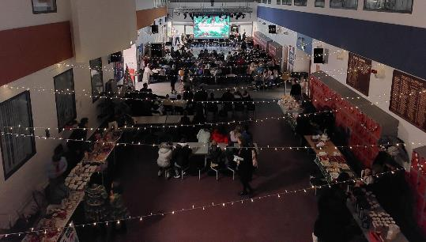

Some useful information contacts for parents to find out more on education are as follows:

- Parentzone – www.parentzonescotland.gov.uk
- Engage Parent Forum – www.engageforeducation.org
- National Parent Forum for Scotland – www.educationscotland.gov.uk/parentzone
- South Lanarkshire Council – www.southlanarkshire.gov.uk

Communication
We want to have direct, easy and open communication with all parents. Communication between school and home is very important. There are a wide range of reasons for communicating so we use various methods to ensure that we keep in touch with you. The range of methods we use include letters, phone calls, text messages, emails, leaflets and reports. We are up-dating our website and you will be able to access information and news that way too. I send out about 4 or 5 newsletters to parents every session which are also placed on the website. We have curriculum evenings, showcase events and concerts at various times through the session.
You can communicate with us by phoning, arranging to come in to meet the person you need to talk to, emailing, writing a letter or through writing a note in your child’s homework planner. If we cannot communicate with you immediately, we shall try to respond as soon as possible, preferably within 24 hours. Urgent information – for example if the school cannot open due to inclement weather – is announced via local radio stations and text messages, if we can get into the school that is!

4. School Ethos
Our values are respect, honesty, ambition, resilience and equity. We have received our Recognition of Commitment (RoC) from UNICEF and are now working towards becoming a Rights Respecting School. These values permeate all aspects of our school within a caring ethos. This ethos supports the wellbeing of everyone within the community, with an emphasis on respect for others as well as for self. We are very aspirational for our pupils and strive to help them attain and achieve at the highest possible level and extend this ambition to every individual pupil no matter their background or learning need. We provide an ethos where young people thrive; and we know that they thrive when their teachers, parents/carers and pupils themselves all work together with the same vision in mind. It is essential in the 21st century that we equip young people with skills for learning, life and work if they are to be resilient, successful and happy in life so we promote these skills through learning and teaching, through the curriculum and through our achievement agenda.
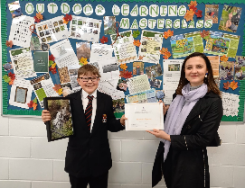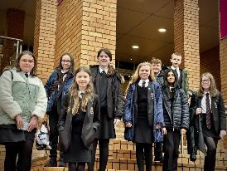
We work closely with other agencies to ensure that we get it right for every child. We have excellent links with organisations such Healthy Valleys, Integrated Children’s Services, Skills Development Scotland (formerly the Careers Service), local businesses and colleges and universities.
Our local community links continue to strengthen: local businesses support careers events and enterprise activities; some sponsor our football teams; our band and choir often provide entertainment for local groups; senior pupils undertake community involvement and we have sports ambassadors who build fitness capacity within their own communities.

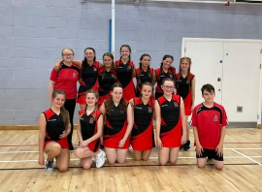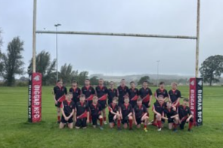

Pupil Voice
We work in partnership with pupils and appreciate that good partners listen to each other. Through the year, we ask pupils for their views and opinions. Departments often ask pupils to evaluate units of work; Pupil Support teachers frequently involve pupils in discussions about a range of issues; and we have questionnaires and surveys that gather views. A vital part of ensuring that pupils have a voice is the Pupil Council. Every class chooses a representative who sits on the Pupil Council for a school year attending meetings, discussing issues raised by pupils and communicating with their classmates.
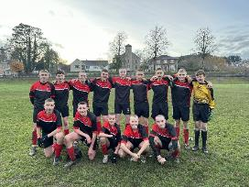

Pupil Leadership Team and Prefect System
This year the school introduced a Junior Pupil Leadership team in addition to our Senior Pupil Leadership team. Our Junior Pupil Leadership team consists of two Captains and three Vice Captains. Our Senior Pupil Leadership team consists of two School Captains, two Vice School Captains, an Equity and Inclusion Captain and two Health and Wellbeing Captains. Both teams consist of pupils who nominated themselves to be considered for these roles.
To be part of the Senior Pupil Leadership team, pupils are nominated and deliver a speech to S6 pupils and staff. S6 pupils and teachers then vote for their preferred candidates. Following this they are interviewed by a panel including a previous School Captain. Performance at the interview and the results of the vote are taken in to account and the Senior Pupil Leadership Team are duly elected. To be part of the Junior Pupil Leadership team, pupils complete an application form and an interview.
They represent the school at various events, help teachers and pupils in all sorts of ways and act as role models for younger pupils. Prefects from S5 and S6 are chosen by the Senior Management Team and the Pupil Support Team. These are pupils who have shown leadership skills and, again, have shown that they are excellent role models.
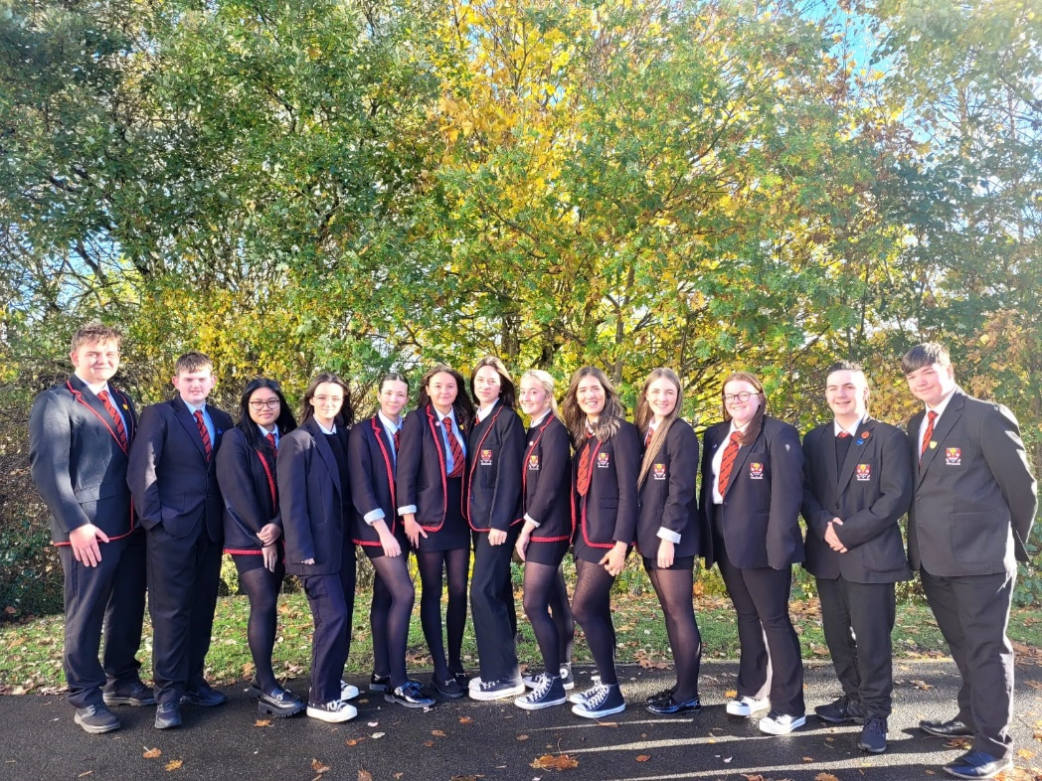
Promoting Positive Relationships
It is the responsibility of senior staff to ensure that staff, parents and pupils are involved in the creation of a positive school ethos that encourages good behaviour. Equally, the school, whilst promoting positive behaviour, must support young people should unacceptable behaviour or bullying occur. Parents have a significant role to play so that we can work in partnership where everyone knows what is expected of them in trying to change the behaviour and attitudes that contribute to bullying behaviour.
Our approach is to create an environment where better behaviour will encourage better learning; an environment where everyone can work together, be safe and enjoy learning.
Incidents of bullying should be reported to the school immediately so that each alleged incident can be investigated and logged. Together we can work towards creating a safer school for children and staff.
In addition, a guideline (Promoting Positive Relationships and Understanding Distressed Behaviour) has been produced to support all teaching and support staff and inform them of their roles and responsibilities when dealing with the small number of young people who display challenging behaviour. Early identification is crucial so that intervention can be provided to support pupils and help them address their issues and concerns. Staff training is provided to help develop the skills needed to respond to, and manage, challenging behaviour. A wide range of appropriate staff development opportunities has been developed for this purpose.
The school works hard to promote positive behaviour. Over the last few years, a merit/demerit initiative has been introduced which sets out to recognise and reward pupils who are hardworking and reflect the values of the school. Teachers can now award a merit for consistent effort, positive behaviour, to reward a specific piece of work or homework or for citizenship within the classroom. These merits are recorded and pupils are invited to participate in regular reward events, such as cinema mornings, trips, raffles, and being issued with praise letters and certificates. As well as this, teachers can give pupils demerits for poor effort, disruptive behaviour, and non-completion of homework which limit a pupil’s opportunity to participate in rewards. Parents are regularly updated with merit/demerit totals to allow them to encourage self-reflection and self-improvement in the pupils. The school feels it is important to keep the focus on and recognise positive behaviour and adopt a proactive, not reactive, attitude to the negative.

As part of our positive behaviour strategies, staff use various approaches to engage pupils in their learning and teaching. When a pupil fails to follow the teacher’s instructions or disrupts either their own learning, or the learning of others, a system of sanctions may be used. Each of these sanctions is designed to give the pupil opportunities to amend their behaviour and allow them to engage with the lesson.
These include:
- Verbal warning – to alert the pupil of the inappropriate behaviour
- Asked to step outside class – to allow the pupil to reflect on the behaviour and if necessary calm down
- Demerit or lunchtime detention issued
- Removal from a particular class activity

Lesmahagow High School does not issue punishment exercises. When a pupil misbehaves in class the teacher may issue the pupil with an Incident Reporting Card which gives a description of the incident. We would ask you to discuss this with your child. There is a comment box, which you should complete with your child, to indicate the result of this discussion and the actions the child will take to amend the behaviour. This should be signed by a parent at home and returned to the teacher. By using this system both children and parents can play an active role in helping create a positive learning environment and engage in the learning process. This system is proving more successful in promoting positive behaviour than the previous system, not surprising as it was the pupils themselves who suggested that this was the best sanction for poor behaviour!
Occasionally some pupils fail to improve their behaviour even though the above opportunities have been provided. In these cases, the following sanctions may be used:
- Referral to Principal Teacher
- Department monitoring card
- Contact with home by Principal Teacher
- Temporary removal from class
- Meeting with parents
- Referral to Principal Teacher Pupil Support or Depute Head Teacher
- Whole school monitoring card
- Internal exclusion
- Exclusion from school

How else can parents help?

The best way you can help is through setting high standards of behaviour for your child and working in real partnership with the school.
By helping your child come to school each day with all they require for the day’s work ahead, including full PE kit when needed
Checking your child’s planner and assisting in the completion of homework tasks
Ensuring they are always in full school uniform
Encouraging and reminding your child that if they insist on bringing a mobile phone, it must be out of sight and switched off during all classes. (Please note that if a pupil’s phone is on during class time he/she will be asked to give it to a member of staff and collect it at the end of the school day).
The school greatly appreciates the support parents give us in promoting a positive learning environment and recognise that you have the greatest influence on your child. We look forward to working with you as partners to ensure your child has a positive learning experience at Lesmahagow High School.

5. The Curriculum
Curriculum for Excellence is the name given to the curriculum in Scotland for all children and young people aged 3-18. It is a forward-looking, coherent, more flexible and enriched curriculum that provides young people with opportunities to engage with the knowledge, skills and attributes they will need if they are to flourish in life, learning and work, now and in the future.
The curriculum includes all of the experiences that are planned for children and young people to support the development of their skills, wherever they are being educated, for example in the family and community, pre-school centre, nursery and school. In secondary school setting the broad general education (BGE) will provide them with opportunities to become successful learners, confident individuals, responsible citizens and effective contributors to life in the 21st Century. The Senior Phase that follows on from the BGE will provide learners with the opportunity to achieve a wide range of qualifications to recognise their learning.
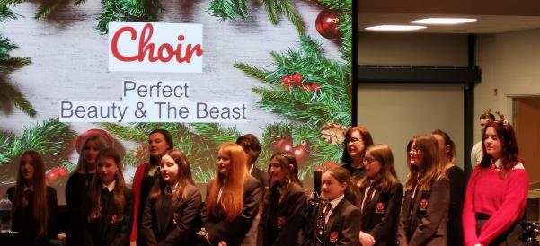
In taking this forward our school will work closely with South Lanarkshire Education Resources and other services to enable Curriculum for Excellence to be fully embedded, ensuring the best possible education for all children and young people. We wish you to feel confident that your child is encouraged and supported to develop their literacy, numeracy and other skills whilst they attend our school. The curricular areas for the Broad General Education are as follows:
- Expressive arts
- Languages and literacy
- Health and wellbeing
- Mathematics and numeracy
- Religious and moral education
- Science
- Social studies
- Technologies

In the Senior Phase (S4-6), learners are asked to personalise their learner journey and work towards achievement of relevant and appropriate qualifications (including National Qualifications).
If you want to know more about Curriculum for Excellence, please visit these websites: Scotland's Curriculum for Excellence (scotlandscurriculum.scot)
Our learning and teaching activities are based on the outcomes and experiences in the guidelines that all schools have for Curriculum for Excellence.
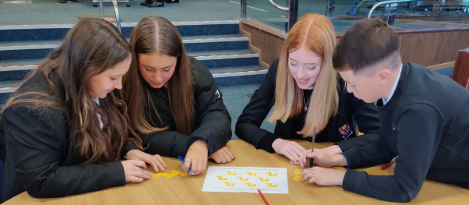

Level Stage
Early The pre-school years and Primary 1 or later for some.

First To the end of Primary 4, but earlier or later for some.

Second To the end of Primary 7, but earlier or later for some.

Third and Fourth S1 to S3, but earlier or later for some. The Fourth Level broadly equates to Scottish Credit and Qualifications Framework level 4. The Fourth Level experiences and outcomes are intended to provide possibilities for choice and young people's programmes will not include all of the Fourth Level outcomes.
Secondary 1 to Secondary 3, but earlier for some the fourth level broadly equates to SCQF level 4.

Senior Phase Secondary 4-6 and college or other means of study.

We offer a broad general education to all pupils in S1, S2 and give S3 pupils a certain amount of choice within each curricular area.



Examples of art and technical work

Information Technology
Every financial year, we aim to improve the IT resources within the school. At the moment, we have 5 classrooms each housing 20 computers for pupil use. Particular subjects like computing, graphic communication and business education use these classrooms extensively although the classrooms can be booked by other subject departments when they are available. We also have 2 classroom-in-a-box sets which contain 20 chromebooks each; one is available for booking to any classroom and the other is situated in the library. We have numerous alpha smarts which individual pupils can access. We have interactive white boards and projectors in most of our classrooms which teachers use to deliver high quality and interesting lessons.


Spiritual, Social, Moral and Cultural Values (Religious Observance) *
Rights of Parents / Carers
Scottish Government Ministers consider that religious observance complements religious education and is an important contribution to pupils’ development. It should also have a role in promoting the ethos of a school by bringing pupils together and creating a sense of community.

Time for Reflection – Our Mission Statement
We are committed to nurturing our young people in their physical, emotional, social and spiritual well-being through our curriculum, through our values and through learning and teaching. The aim is to help all pupils to grow and develop their own sense of themselves, to be confident in expressing their own beliefs and values, and to develop an understanding of and empathy towards others. Our commitment to this can be found in many aspects of school life: such as through assemblies; active religious observance; creating time for reflection and through religious and moral education, all of which provide opportunities for the school community to reflect on, develop and celebrate the shared values of our school.
Lesmahagow High School plays an important role in the life of the local community. As such, working with our Chaplaincy Team, we seek to include shared community values when delivering regular assemblies and services that sensitively engage, stimulate and benefit pupils in their individual beliefs and values, whether they are of a particular faith or none. We shall endeavour to ensure that the Chaplaincy Team represents a range of beliefs and viewpoints as required by Education Scotland.
Religious observance and time for reflection in Lesmahagow High School adopts an open and respectful approach and does not seek to compromise the beliefs of any member of the school community.

Equalities
Integral to this guidance is the principle of mutual respect. The diversity of belief and tradition provides an ideal context in which pupils can learn about, and so learn from, what is important in the lives of themselves and others. South Lanarkshire’s guidance recognises and welcomes diversity and promotes respectful understanding.
Parents may request that their children be permitted to be absent in order to celebrate recognised religious events. Advance notice should be provided to the school when children will be absent. Appropriate requests will be granted and the pupil noted as an authorised absentee in the register.
6. Assessment and tracking progress
Proper assessment supports and reinforces quality learning and teaching and plays a central part in raising attainment and achievement. Teachers use their knowledge of pupils’ work, check pupils’ skill level, judge attributes and capabilities to assess pupil progress and set next steps. Pupils are involved in the assessment process showing how secure they are in their learning, displaying their knowledge and understanding and their developing skills to the teachers, to their peers and to themselves. Pupils play an important in agreeing their next steps in learning with their teachers. Teachers gather information and evidence about how pupils are progressing through:
- Observing learning – practical investigations, art work, performance, discussions, question and answer sessions, quizzes, portfolios, jotter work, homework tasks, written work, multiple choice
- Checking knowledge and understanding
- Organising peer and self-assessment
- Marking and analysing end of unit tests

Departments retain information about how individual pupils are doing in different ways; some keep a folio of work, some keep marks registers with comments, some keep pieces of created work etc.
We want to share information with you on how your child’s learning is progressing. We do this through three tracking reports. Subject departments and Pupil Support teachers monitor progress from year to year and track pupils’ progress through the entire curriculum.
Teachers work together to ensure that agreed standards are set. Teachers across schools meet in subject sets to compare results and to check the validity of their assessments with each other. South Lanarkshire Council and the SQA also provide opportunities for moderation exercises to ensure that standards are understood, shared and met.
7. Reporting
We will report to parents regularly so that you can see what your child is doing and how they are progressing. Part of this reporting process will include parents’ meetings which offer you the opportunity to discuss how your child’s progressing and how you can contact the school if you wish further information. The school will offer you an appointment time so that you can have a discussion about your child’s education.
Reporting will help you to get to know more about the curriculum which each young person follows and will describe their strengths, achievements and areas for development so you know what encouragement and support you can give.
We welcome any comments or additional information from parents to help us provide the best possible education for your child.

8. Transitions
Pupils typically transfer from primary to secondary school between the ages of 11½ and 12½, so that they will have the opportunity to complete at least 4 years of secondary education. Arrangements are made by the school to transfer children to the associated secondary school as determined by their home address. Parents of P7 children will be informed of the transfer arrangements made for their child to attend secondary school.
We will also provide you with information at this time on events designed to support P7 children before they move on to secondary school.
Typically children attend the school in their catchment area. Our associated primary schools are: Bent Primary, Blackwood Primary, Coalburn Primary, Milton Primary and Woodpark Primary. However, there are times when parents may wish their children to go to other schools. If you wish your child to go to another school then you may make what is known as a ‘placing request’. If you live in South Lanarkshire and decide to submit a ‘placing request’, we are unable to reserve a place in your catchment school until the Council have made a decision on the ‘placing request’. Please note if your ‘placing request’ application is unsuccessful and all places at your catchment school are filled you will be offered a place at the next nearest appropriate South Lanarkshire School.
Please note that if an application for a ‘placing request’ is successful then school transport is not provided.
If you move out with your catchment primary school a ‘request to remain form’ must be completed. If you move out with your catchment primary, this may affect your right to transfer to the associated Secondary School. Please note the secondary school is determined by the pupil’s permanent home address and chosen denomination. If you require further information, please contact Education Support Services on edsuppserv.helpline@southlanarkshire.gov.uk or 0303 123 1023.

Primary – Secondary Liaison
One of the main aims of the transition process is to get to know each individual Primary 7 pupil by gathering information which will help support the pupil when they come to Lesmahagow High School in August. To do this we engage with the key personnel in the pupil’s life: parents, P7 teacher, Primary Head Teacher, and Support for Learning/Inclusion staff. It is about building relationships which will help raise awareness and reduce pupils’ and parents’ potential concerns.
A full programme of Primary/Secondary liaison runs throughout the year and regular meetings are held between our own teachers and those of our associated primaries. In the second term, members of the Senior Management Team, the Pupil Support Team and Support for Learning/Inclusion Staff visit all primary schools to meet with the P7 pupils and to discuss the needs of individual pupils with our primary colleagues.
There is typically a two day visit to the school in June for all incoming S1 pupils, where they meet and work with the pupils in their new S1 class and, through following their S1 timetable, meet their new teachers. They will also meet their Principal Teacher Pupil Support and Support for Learning/Inclusion staff, who will support them in all aspects of their education throughout their time at school. Our transition programme also includes other activities to enhance the transition for those who require it.
For pupils with additional support needs, there are further transition visits to allow pupils to get to know one another prior to starting in August. This enhanced programme is in recognition of the fact that pupils with ASN come from a wide range of primary schools and will benefit from enhanced support in making this significant change.
Joint working is continuing to take place with our associated primaries to enhance curriculum provision at transition through the ongoing implementation of Curriculum for Excellence (CfE). This focus includes an emphasis at transition in Literacy, Numeracy, Modern Languages and Science (with other areas to come on board at a later date).
We hope that all of the above activities help us to gain an understanding of individual pupils, their curricular experiences and individual progress and, therefore how best to meet their needs.

9. Support for Pupils*
Getting it right for every child.
Getting it right for every child (GIRFEC) supports families by making sure children and young people can receive the right help, at the right time, from the right people. The aim is to help them to grow up feeling loved, safe and respected so that they can realise their full potential.

Most children and young people get all the help and support they need from their parent(s), wider family and community but sometimes, perhaps unexpectedly, they may need a bit of extra help. GIRFEC is a way for families to work in partnership with people who can support them, such as teachers.
If you have any concerns about your child’s wellbeing, you can speak to the named person who will work with you to provide support and decide how to move forward. Your school will let you know who this is. It is likely to be the Head Teacher in a primary school and a principal teacher (pupil support) in Secondary.
More information can be found on: www.scotland.gov.uk/gettingitright

Support for All (Additional Support Needs)
Lesmahagow High School supports many pupils with a wide range of Additional Support Needs. This support was expanded further in August of 2020 when the school gained a specialist provision (Inclusion Support). The Inclusion Support Team is a growing provision which is flexible in its approach to meeting the needs of pupils. The Inclusion support Team utilise a range of strategies across the curriculum to ensure all pupils have the same opportunities, experiences and entitlements as others within the school; these experience are delivered in innovative and creative ways which engage, enthuse and motivate learners.
Enquire is funded by the Scottish Government to provide information on the framework for supporting children who require additional support for learning and to encourage positive partnerships between families, schools and local authorities to ensure children get the right support.
Enquire – the Scottish advice service for additional support for learning Enquire offers independent, confidential advice and information on additional support for learning through:
Phone Helpline: 0845 123 2303
Address: Enquire Children in Scotland Rosebery House 9 Haymarket Terrace Edinburgh EH12 5EZ
Email Enquiry service: info@enquire.org.uk Advice and information is also available at www.enquire.org.uk
Enquire provides a range of clear and easy-to-read guides and fact sheets including the parents’ guide to additional support for learning.
If you would like to order our leaflets, postcards or guides to share with parents and carers of pupils in your school, please contact us on info@enquire.org.uk

Attachment – what we do to support children and young people
South Lanarkshire Council Education Resources is committed to improving outcomes for children and young people by creating emotionally supportive learning experiences in our nurseries and schools.
The Education Resources Attachment Strategy supports the action in the ‘Getting it Right for Every Child in South Lanarkshire’s Children Services Plan 2021-23’, following the launch of the Attachment Strategy in 2020, to provide staff training in Attachment and Trauma based practice.

What does it set out to do?
The aim of the strategy is to promote better experiences of attachment for South Lanarkshire’s children and young people and to ensure that all education practitioners understand the importance of attachment and how positive relationships can make a difference to outcomes.

How can I find out more?
South Lanarkshire Council Education Resources have published a series of leaflets and posters for parents/carers which aim to share information on attachment theory and on how this can inform the ways in which we support children and young people. These are available in schools and on the SLC Staff Learning Centre Sway accessible by teachers and staff. The Education (Additional Support for Learning) (Scotland) Acts 2004 and 2009 set out an integrated approach to the delivery of services and support for young people. There is a wide range of factors which may give rise to additional support needs. Such factors fall largely into the following four categories:
• Learning environment;
• Family circumstances;
• Disability or health need; and
• Social and emotional factors

It is important to recognise that a young person may have additional support needs arising from one, a combination, or indeed all of the above factors. Likewise, additional support needs can be prolonged or enduring or indeed short lived. Notably, pupils who are particularly able or talented also fall into the category of having identified additional support needs. Indeed, almost all learners may require some additional support at some point in the school career. The school actively plans to meet the wide range of needs learners have. The two main plans which exist to support this are:
• Additional Support Plan (ASP). This plan now includes individual targets alongside the inclusion of a designated section for pupils who are “looked after away from home”. The ASP will detail the factors giving rise to additional support needs as well as detailing the young person’s strengths and targets/ development needs.
• Co-ordinated Support Plan (CSP). Where a CSP is required, it will have been recognised that the young person will require support from services out with Education. The premise for opening a CSP is that interventions/support are/is significant enough to require coordination. The CSP is a statutory document which is subject to regular monitoring and review. Currently, we have seven young people within the school who have a CSP.

Inclusion is at the heart of Scottish education and is central to ensuring that all young people are provided with every opportunity to achieve their full potential. Whilst Inclusion has always featured as a key aspect of comprehensive education, recent legislation aims to ensure that each local education authority and individual school has a responsibility for meeting the individual needs of each individual pupil. The emphasis is therefore firmly centred on meeting individual needs.
It is important to recognise that Additional Support Needs legislation does not sit in isolation within Scottish education. It is interlinked with other prominent policies and developments such as the implementation of Curriculum for Excellence and the Getting it Right for Every Child (GIRFEC) agenda.
Should you have any concerns or queries relating to any aspect of Inclusion in general, or to the needs of your daughter/son in particular, staff working in this area will be glad to offer you any assistance.
Supporting young people’s learning across the school is the shared responsibility of all staff, however there are specific designated staff who have a lead role in taking forward Inclusion and in supporting staff, teaching and non-teaching, to ensure that all pupils are supported in accessing an appropriate curriculum and in meeting the wide range of pupils’ needs across the school.
South Lanarkshire Education Resources have published a series of leaflets available which cover information for parents and carers about the Additional Support for Learning Acts.

10. School Improvement
The main emphasis of the school’s improvement agenda for the last few years has been improving the attainment and achievement of pupils at all levels. Much of our development time for the last 3 years has been spent focussed on developing and delivering the new curriculum and qualifications.
Over the next 3 years, we shall concentrate on continuing to develop the curriculum and regularly evaluating the experiences of pupils through each stage. Pupils and parents will be involved in these evaluations and instrumental in helping us to improve attainment, achievement and health and wellbeing for all. The School Improvement Plan for 2022-23 concentrates on the following:
- Health and Wellbeing
- Inclusion, Equity and Equality
- Raising Attainment
- Skills for Learning, Life and Work
- Leadership and Sustainability

A full copy of the school improvement plan can be downloaded from the school website.

We offer a range of experiences to pupils that offer them the opportunity to achieve:
- Class Representative
- Pupil Council
- Rights Respecting Schools Group
- Outdoor education trips
- Theatre trips
- Various Trips – London, Edinburgh, Glasgow, Barcelona, Paris, Iceland and Italy
- Charity work
- Community involvement
- Classroom helpers
- Sports ambassadors
- Work experience
- Clubs and activities
- Various sports teams
- Inter-House events
- Duke of Edinburgh Award

11. School policies and practical information
School Meals
Healthy eating is something that the school supports and a range of meals are available at lunchtime that meet the Nutritional Requirements for Food and Drink in Schools (Scotland) Regulations 2020.
The secondary school menu includes a range of options available from breakfast, mid-morning and lunchtime.
- A meal deal for £2.00 consisting of a choice of main meal served with two portions of vegetables/salad and seasonal fresh fruit selection
- A selection of Grab ‘n’ Go snacks that are individually priced including panini, pizzini and freshly prepared baguettes and sandwiches with selection of fillings
- “Beat the Queue” use our new Pre-order Fusion Mobile App where mid-morning snacks and lunches can be ordered via mobile phone and pick it up during mid-morning and lunch break avoiding queues. See South Lanarkshire Council website for details on how to sign up.
Fresh drinking water is also available with all meals
NB School Meal prices are reviewed annually and may be subject to change
Special diets
If your child within Nursery, Primary or Secondary requires a special diet for medical reasons please speak to the school/nursery office who will provide the request form for you to complete. In addition, if you have a cultural diet request for your child please speak to the school office who will provide you with a request form.
*Free School Meals
Children of parents who receive the following benefits are entitled to a free lunchtime meal for their child
- Income Support, Universal Credit (where your take home pay is less than £660 per month), Job Seeker’s Allowance (income based), Employment and Support Allowance (income related), Working Tax Credit and Child Tax Credit (where your gross annual income does not exceed £7,920 as assessed by the HM Revenues and Customs), Child Tax Credit Only (where your gross annual income does not exceed £17,105 as assessed by the HM Revenues and Customs) or receive support under Part VI of the Immigration and Asylum Act 1999. ( Please check current criteria with SLC website – there is auto enrolment)

If you are in receipt of Housing Benefit and/or Council Tax Reduction from us there is no need for you to apply online, we will use the information we hold to automatically award free school meals (P4 to S6) and/or school clothing grants (P1 to S6) to eligible families.
We would encourage parents of pupils who are in receipt of any of the above benefits to take up this opportunity of having a meal provided for their child when they are at school. All secondary schools operate a cashless school meals system which protects the anonymity of pupils entitled to a free school meal.
We encourage all pupils to remain in school at lunch times.

*Education Maintenance Allowance
EMA is available to young people between 16 and 19 years of age and is awarded depending on your household’s gross taxable income and the number of other dependent children living with you.
The online application form and information is available from South Lanarkshire Council website www.southlanarkshire.gov.uk
If the online form is not an option, please contact your school office for assistance.

School uniform
We ask all parents/carers to support the school by encouraging your child(ren) to adhere to the agreed dress code and the wearing of our school uniform. The wearing of a school uniform helps promote the identity of the school in the local community and helps create an ethos of sharing and pride in the school.
In addition, the wearing of a uniform helps towards increasing the protection of all pupils. The wearing of a uniform helps staff and the pupils to distinguish between who belongs to the school and those who may be visitors. This enables staff to approach and identify visitors more readily and helps in trying to offer a safer environment for pupils and teachers alike.
Equality of opportunity is an important aspect of the life of the school. Any proposals on the dress code and on what constitutes the school uniform will be the subject of discussion with the Parent Council and where appropriate consultation with parents, pupils and staff.
There are forms of dress which are unacceptable in all schools such as:
- the wearing of football colours
- clothing with slogans that may cause offence (anti-religious, symbolism or political slogans)
- clothing which advertises alcohol, tobacco or drugs
- clothing which can be deemed unsuitable in terms of health and safety grounds such as shell suits, combat style clothing, dangling earrings, loose fitting clothes particularly in practical classes
- articles of clothing that could be deemed to inflict damage on other pupils or be used by others to do so
- Footwear that may be deemed to damage flooring.

Uniform for all pupils in Lesmahagow High School:
- White Shirt / Blouse (no black shirts)
- Lesmahagow High School Tie
- Plain black V-neck Jumper / Cardigan (without logos)
- Black Skirt / Trousers (no jeans/no leggings)
- Plain black footwear (including laces)
- School Blazer

Our school blazers suppliers are Scotcrest. Blazers can be ordered online at www.scotcrestschool.co.uk, at the Scotcrest shop in Hamilton and from ALJ Work and Leisurewear in Lanark.

Allergies
A significant number of children and young people in our schools will have allergies and it is important that parents keep the school fully informed on these matters.
Allergies can present in a variety of ways and can occur at any point in a person’s life. Symptoms range from mild to severe. Children and young people known to have an allergy with moderate to severe symptoms will likely have a Health Care Plan drawn up by the NHS. This will detail symptoms and appropriate interventions.
It is vital that parents share this information with the school and continue to provide any updated information.
Where symptoms are mild and a Health Care Plan is not in place, parents should still continue to liaise regularly with the school on any new triggers, medications and actions required.
In all cases, our employees need to know your child’s symptoms, treatments and any actions required to help prevent exposure to the allergen and minimise the risk of allergic reactions.
Employees in schools will receive training on allergies and will liaise with parents and NHS on any additional specialist training required.
In supporting children and young people with allergies, school employees will operate in accordance with South Lanarkshire Council’s Safe Systems of Work / risk assessment and national guidance on the administration of medicines.

Support for parent/carers
*Clothing grant
In certain circumstances the Council provides support to parents/carers for the purchase of school wear.
Application can be made online at www.southlanarkshire.gov.uk If you are required to submit evidence of your Tax Credit income, it is important that a copy of this evidence is attached to your online application. Should you require further information or you are unable to submit an application online, then please contact the helpline number 0303 123 1011 (option 5).
School hours/holiday dates
The School Day
Our school day is different from our primary schools. From Monday to Thursday, pupils begin lessons at 8.40 every morning; have 7 periods of different subjects and finish at 3.35 pm.
On Friday, school begins at 8.40 am with 4 periods and ends at 12.30 pm.
Period Times – Mon-Thurs |  |  |  | Period Times – Friday
 | Start | Finish |  |  | Start | Finish
Tutor Time | 8.40 am | 8.50 am |  | Tutor Time | 8.40 am | 8.50 am
Period 1 | 8.50 am | 9.40 am |  | Period 1 | 8.50 am | 9.40 am
Period 2 | 9.40 am | 10.30 am |  | Period 2 | 9.40 am | 10.30 am
Senior Phase  Interval  Period 3 | 10.30 am  10.45 am | 10.45 am  11.35 am |  | Senior Phase Interval  Period 3 | 10.30 am  10.50 am | 10.50am  11.40 am
BGE  Period 3  Interval | 10.30 am  11.20 am | 11.20 am  11.35 am |  | BGE  Period 3  Interval | 10.50 am  11.20 am | 11.20am  11.40 am
Period 4 | 11.35 am | 12.25 pm |  | Period 4 | 11.40 am | 12.30 pm
Period 5 | 12.25 pm | 1.15 pm
Lunch | 1.15 pm | 1.55 pm
Period 6 | 1.55 pm | 2.45 pm
Period 7 | 2.45 pm | 3.35 pm

Enrolment
To enrol your child in the school, please contact the school office. Year Heads arrange enrolments, S1/S4: Mr Gray; S2/S5: Mrs Cimmino; and S3/S6: Mr Robertson. When enrolling your son/daughter please bring your child’s full birth certificate and two letters showing proof of your address, e.g. utility bill, Council Tax letter, etc.

Transport*
School transport
South Lanarkshire Council has a policy of providing school transport to Secondary pupils who live more than two miles by the recognised shortest safest walking route from their catchment school. This policy is more generous than the law requires. This means that the provision of transport could be reviewed at any time. Parents who consider they are eligible should complete a form online www.southlanarkshire.gov.uk or contact 0303 123 1023. These forms should be completed and returned before the end of March for those pupils starting the school in August to enable the appropriate arrangements to be made. Applications may be submitted at any time throughout the year and will be considered by Education Resources.
A paid privilege transport scheme is operated for mainstream school contracts where a pupil is not entitled to free school transport. Privilege transport will only be granted providing there is spare capacity on an existing school contract and will be from and to designated pick up and drop off points. Privilege transport will not be provided where a service bus is used on the school run. Any spare capacity will be allocated using agreed priorities.
More information on school transport is available at:
www.southlanarkshire.gov.uk/info/200188/secondary_school_information/545/school_transport or phone 0303 123 1023.

Pick-up points
Where school transport is provided it may be necessary for pupils to walk a certain distance to the vehicle pick-up point. Walking distance in total, including the distance from home to the pick-up point and from the drop-off point to the school in any one direction, will not exceed the authority’s distance limit for school transport.
It should be noted that it is the parent’s responsibility to ensure their child behaves in a safe and acceptable manner while travelling in and alighting from the vehicle. Misbehaviour can result in your child losing the right to school transport.

Parents are asked to note that South Lanarkshire Council does not provide transport for those pupils who attend school via a placing request.

Any information on transport appropriate to the school should be mentioned.

Insurance for schools – pupils’ personal effects
South Lanarkshire Council is concerned at the level of claims being received for loss or damage to pupils’ clothing or personal effects. Parents are asked to note the Council’s position in terms of insurance for pupils’ personal effects:
(i) Theft/loss of personal effects
The Council is not liable for the loss or theft of pupils’ clothing or personal effects for example mobile phones, tablets etc. and any items are therefore brought into the school at the pupil/parents’ own risk.
Parents can assist by ensuring that valuable items and unnecessarily expensive items of clothing are not brought to school.
Teachers and other staff have been advised not to accept custody of any such items.
The same principle applies to musical instruments and other equipment used for activities within the school, which belong to the pupil, but are brought into the school. Parents should be aware that if such equipment is left in school, it is done at the pupil/parents’ own risk.
In the case of valuable items such as musical instruments, parents should ensure that these items are covered by their own household insurance.
(ii) Damage to clothing
The Council is only liable for damage caused to pupils’ clothing where the damage has resulted from the negligence of the Council or one of its employees. Claims arising otherwise will not be accepted by the Council’s insurers.

Family holidays during term time
Family holidays should be avoided during term time as this both disrupts the child’s education and reduces learning time. If holidays are taken during times when the school is open parents should inform the school in advance by letter.
If your child is taken on a family holiday during term time then in line with Scottish Government advice this will be classified as an unauthorised absence. However, in exceptional circumstances schools may register a family holiday during term time as an authorised absence when for example, parents are unable to obtain leave during the school holiday period.
Clearly, absence with no explanation from parents will mean that the absence will be recorded as unauthorised.
In our approach to raising attainment and achievement it is recognised that attendance at school is something that should be continuously encouraged. Parents/carers, children and the school all have a part to play in encouraging and stressing the importance of attendance at school.
Every effort should be made to ensure that your child attends school during term time. Please contact the school as soon as possible if your child is unable to attend school.
The school holiday dates and in-service dates are available from the website www.southlanarkshire.gov.uk

Promoting positive behaviour
It is the responsibility of staff within the school to ensure that parent council members, parents and pupils are involved in the creation of a positive school ethos that encourages good behaviour. Equally, the school whilst trying to promote positive behaviour must support young people should incidents or bullying occur. Parents have a significant role to play in working with the school so that teachers, parents and pupils know what is expected of them in trying to change the behaviour and attitudes that contribute to bullying behaviour.
Our approach is to create an environment where better behaviour will encourage better learning. The school, along with the support of parents, can work together to create a learning environment which young people can enjoy and feel safe.
Incidents of bullying should be reported to the school immediately so that each alleged incident can be looked at. Together we can work towards creating a safer school for children and staff.
In addition, a guideline (Promoting Positive Relationships and Behaviour) has been produced to support all teaching and support staff and inform them of their roles and responsibilities in respect of dealing with the small number of children and young people who display challenging behaviour. Early identification is crucial so that intervention can be provided to support children and young people to help them address their issues and concerns. Staff training is provided to help develop the skills needed to respond to and manage challenging behaviour. A wide range of appropriate staff development opportunities has been developed for this purpose.

Child Protection
All staff in educational establishments in South Lanarkshire Council receive an annual Child Protection update and are required to follow the advice and guidance contained within relevant Education Operating Procedures. They must also complete a mandatory Learn on Line Course “Child Protection in Education”.
South Lanarkshire’s children’s services partnership works together to support children, young people and their families so that children grow up in communities where they are safe, healthy, active, achieving, respected, responsible and included, and have the opportunity to achieve their full potential. They are committed to continuously improve our services to ensure children, young people and their families get the right support at the right time.
Sometimes children and young people need additional help to make sure that they are “cared for and protected from abuse and harm in a safe environment in which their rights are respected” (CPC South Lanarkshire Child Protection shared vision). The Child Protection Committee has the overarching responsibility to ensure that agencies individually and collectively work to protect children and young people as effectively as possible.
All staff have a responsibility to report any suspicions that a child has been abused or is at risk of harm, abuse, or neglect. Robust procedures and guidance are in place to support education staff to:
- be alert to signs that a child may be experiencing risks to their wellbeing,
- report concerns to the head of establishment or the child protection coordinator without delay.
- be actively engaged in support and protection and development of wellbeing.

If you would like more information, or have a concern of a child protection nature, please contact the head of the educational establishment which your child attends.
The Child Protection Committee’s website has a range of useful information for parents/carers on how to help them keep their children safe. www.childprotectionsouthlanarkshire.org.uk

Information on emergencies
We make every effort to ensure the school remains open during term-time for pupils. However, on occasions circumstances may arise which can affect the school. Schools may be affected by, for example, severe weather, power failures or through any other circumstances that may impact on the school day. In such cases we shall do all we can to let you know if this happens. We shall keep you in touch by telephone, text, where appropriate, letters, web news and through local radio stations particularly if there are prolonged periods of severe weather. The Council’s website www.southlanarkshire.gov.uk will be used to let you know if the school is closed and when it will re-open.
It is important for parents/carers to let the school know of any change to your mobile/home telephone number and change of address.
If for any reason, you are unsure if the school is open visit the website www.southlanarkshire.gov.uk or email us at: education@southlanarkshire.gov.uk

Your commitments
We ask that you:
- support and encourage your child’s learning
- respect and adhere to the schools policies and guidance
- let the school know if you change your mobile/telephone number and/or address
- enjoy and take part in school activities
- accept your responsibility to respect staff who work in the school and for the school to be proactive in taking forward the commitment to care for and educate your child.

General Data Protection Regulation as supplemented by the Data Protection Act 2018 (GDPR)
Information on pupils, parents and guardians is held by the school to enable the teaching, registration and assessment of pupils as well as associated administrative duties. The information is stored and used as per the requirements of the Data Protection Act 1998 with South Lanarkshire Council defined as the data controller. The Council have established a data protection policy that applies to all of its schools. For more information please contact the school.
Education Resources has also prepared a privacy notice (below) which sets out how we will deal with personal information as part of our statutory function as an education authority. For more information please contact the school

Privacy Notice
Introduction
In line with the General Data Protection Regulation (GDPR) we have produced this privacy notice to inform you how we deal with personal information as part of our statutory function as an education authority.
The Council has a legal obligation to deliver effective education services to children, young people and adult learners in South Lanarkshire. In order to do this we need to collect personal information about children, young people and their families so that we can help them to learn and keep them safe.

Using your personal information
The Council is a “controller” of the personal information you provide when enrolling for a nursery or school, applying for an education service or participating in groups or activities provided by Education Resources.

Information we collect from you about you and your child at enrolment
When you enrol for a nursery or school, we ask for the following information:
- parent/carer contact details (names, address, phone, email);
- the child’s name, date of birth, gender and address;
- information about medical conditions, additional support needs, religion and ethnicity;
- any information you may wish to provide

In line with the data protection policy we have produced this privacy notice to inform you how we deal with personal information as part of our statutory function as an education authority.
The Council has a legal obligation to deliver effective education services to children, young people and adult learners in South Lanarkshire. In order to do this we need to collect personal information about children, young people and their families so that we can help them to learn and keep them safe.

Using your personal information
The Council is a “controller” of the personal information you provide when enrolling for a nursery or school, applying for an education service or participating in groups or activities provided by Education Resources.

Information we collect from you about you and your child at enrolment
When you enrol for a nursery or school, we ask for the following information:
- parent/carer contact details (name, address, phone, email)
- the child’s name, date of birth, gender and address
- information about medical conditions, additional support needs, religion and ethnicity
- any information you may wish to provide about family circumstances.

Information we collect at other times
We will also collect information at other times such as when you apply for a benefit, request a service or other support. We will provide an additional privacy notice at these times.
- If you apply for an education service or benefit, such as school transport, free school meals, clothing grant, placing request or EMA, we will ask for personal information as set out above. We will also ask for information about your income for education benefits applications.
- If you make a request for additional support such as an educational psychologist or other support for learning we will ask for more detailed information to allow us to provide the most appropriate support for your family. This may include information about family circumstances or medical conditions.
- If there are concerns about your child’s wellbeing and/or your child has needs that may require additional support, we will wish to work with you to collect and consider information to enable us to help you get the right support at the right time in line with Getting it right for every child approach.

We require this information to ensure that children and young people are educated appropriately, supported, and that we take account of their health and wellbeing. We will also ask you to update this information annually and to tell us when there are changes to your details.

Information that we collect from other sources
As an education authority and as part of our statutory function in accordance with our legal obligations, we receive information from other sources such as the SQA, the NHS or Social Work about you or your child, this includes:
- exam results and assessment information;
- information about health, wellbeing or child protection.

Why do we need this information?
We need this information so the Council can ensure it is delivering education services appropriately to all learners:
- for the education of children, young people and adult learners;
- for teaching, enrolment and assessment purposes and to monitor the educational progress of children, young people and adult learners;
- to keep children and young people safe and provide guidance services in school;
- to identify where additional support is needed to help children, young people and adult learners with their learning;
- to maintain records of attendance, absence and behaviour of children and young people (including exclusions);
- to support children and young people moving on each year from nursery to primary, primary to secondary and when they move or leave school;
- to help us develop and improve education services provided for young people, adult learners or families
- In accordance with our legitimate interests as an education authority we will also use your information to create statistical reports.

We will share your information with:
As an education authority and as part of our statutory function in accordance with our legal obligations we will share information with other bodies or parts of the Council, including:
- The Scottish Government and bodies such as Education Scotland, Scottish Qualifications Authority, Skills Development Scotland and other organisations that support children and young people’s learning;
- Other parts of the Council when required for services such as school meals, school transport, education benefits and with Social work in connection with any child protection concerns we become aware of;
- South Lanarkshire Leisure and Culture Limited, where children and young people are participating in sports and leisure activities;
- Other schools/local authorities – if a child moves or transfers to another school the Council has an obligation to pass on information with regards to pupil records to the new school/local authority.

You have the right to access your personal information as well as the rights of rectification, erasure, restriction and the right to object. For information on these rights and how to exercise them or for information about how we manage your personal information, you can get a copy of our full privacy notice from our website: (https://www.southlanarkshire.gov.uk/info/200235/meta/1730/general_privacy).
Our full privacy notice will also provide information on how to make a complaint or to request a paper copy of the privacy notice from the Data Protection Officer.

12. Foundation Apprenticeships

Each local authority is working with Skills Development Scotland to support the introduction of Foundation Apprenticeships for senior phase pupils. A Foundation Apprenticeship is a new nationally recognised qualification, which has been designed to provide learners with knowledge and skills, relevant to occupations in thriving industry sectors, such as engineering/civil engineering, social & health care, creative design & media, finance/ accountancy/ business, scientific technologies, ICT hardware/ software and food & drink technologies. The SCQF Level 6 courses combine classroom and work- based learning delivered in partnership with employers and specialist learning providers or colleges. Foundation Apprenticeships are the same level as Higher qualifications and can be used as entry requirements for Modern and Graduate Apprenticeships, college and university courses. Pupils gain a valuable insight into the workplace by attending work placements during the Foundation Apprenticeship.
Senior phase pupils can participate in Foundation Apprenticeships as part of their S4-S6 curriculum over one or two years. Available options have been agreed on a local basis.
More details can be found at:
https://www.apprenticeships.scot/become-an-apprentice/foundation-apprenticeships/
Appendix A

This annex gives a list of useful information and the links to the content is now available from the Council’s website by accessing the following link
http://www.southlanarkshire.gov.uk/info/200188/secondary_school_information/1264/curriculum_for_excellence/2
The list is not intended to be exhaustive and authors may wish to consider additional sources of school, local and national information, material and resources.

Contact Details
Education Scotland’s Communication Toolkit for engaging with parents
The Scottish Government Guide Principles of Inclusive Communications provides information on communications and a self-assessment tool for public authorities
Choosing a School: A Guide for Parents - information on choosing a school and the placing request system
A guide for parents about school attendance explains parental responsibilities with regard to children’s attendance at school

Parental Involvement
Guidance on the Scottish Schools (Parental Involvement) Act 2006 provides guidance on the act for education authorities, Parent Councils and others
Parentzone provide information and resource for parents and Parent Councils
National Parent Forum for Scotland; www.npfs.org.uk

School Ethos
Supporting Learners - guidance on the identification, planning and provision of support
Journey to Excellence - provides guidance and advice about culture and ethos
Health and wellbeing guidance on healthy living for local authorities and schools
Building Curriculum for Excellence through Positive Behaviour and Relationships outlines the Scottish Government’s priority actions around positive behaviour in schools and is also a source of support
Scottish Catholic Education Service’s resource ‘This is Our Faith’ which supports the teaching and learning of Catholic religious education

Curriculum
Information about how the curriculum is structured and curriculum planning
Information about the outcomes a learner can expect to experience and achieve across literacy, numeracy and health and wellbeing, as well as the 8 curricular areas
Advice, practice and resources to support the experiences and outcomes on literary, numeracy and health and wellbeing
Broad General Education in the Secondary School – A Guide for Parents and Carers
Information on the Senior Phase
Information on Skills for learning, life and work
Information around the Scottish Government’s ‘Opportunities for All’ programme
Information for organisations responsible for the planning, management and delivery of career information, advice and guidance services
The Skills Development Scotland website ‘My World of Work’ offers a number of tools to support career planning

Assessment and Reporting
Building the Curriculum 5: a framework for assessment provides guidance around the assessment framework
Information about Curriculum for Excellence levels and how progress is assessed

Curriculum for Excellence fact file - Assessment and qualifications
Information on recognising achievement, reporting and profiling
The Scottish National Standardised Assessment- in Scotland, pupils in P1, P4, P7 and S3 complete online standardised assessments in literacy and numeracy as part of their everyday learning and teaching.

Transitions
Curriculum for Excellence factfile - 3-18 Transitions - provides information on the transitions children and young people will face throughout their education and beyond
Career Information, Advice and Guidance in Scotland - A Framework for Service Redesign and Improvement provides guidance on career information, advice and guidance strategy
Choices and changes provides information about choices made at various stages of learning
The Additional support for learning page provides links to relevant legislation and guidance, including the arrangements that should be in place to support pupils with additional support needs
Supporting Children's Learning Code of Practice includes specific requirements on education authorities and others under the new legislation in relation to transition
Enquire is the Scottish advice service for additional support for learning
Parenting across Scotland offers support to children and families in Scotland

Support for Pupils
The Additional support for learning page provides links to relevant legislation and guidance, including the arrangements that should be in place to support pupils with additional support needs
Information about the universal entitlement to support that underpins Curriculum for Excellence
Supporting Children's Learning Code of Practice (Revised edition) - provides Statutory guidance relating to the Education (Additional Support for Learning) (Scotland) Act 2004 as amended
Getting It Right for Every Child and Young Person, is essential reading for anyone involved or working with children and young people, including practitioners working in adult services with parents and carers

School Improvement
Scottish Schools Online - provides a range of school information, including contact details, school roll, facilities, website, inspection reports
Education Scotland’s Inspection and review page provides information on the inspection process
The Scottish Survey of Literacy & Numeracy
Scottish Credit and Qualifications Framework (SCQF)
Scottish Qualifications Authority provides information for teachers, parents, employers and young people on qualifications
Amazing Things - information about youth awards in Scotland
Information on how to access statistics relating to School Education

School Policies and Practical Information
Schools and local authorities should consider the most relevant school, local and national policies and include details or links for parents to sources of further information.
National policies, information and guidance can be accessed on the following:
Education
Health
Young People
Children (Scotland) Act 1995
Standards in Scotland's Schools (Scotland) Act 2000

